

**UNIVERSITY OF BUEA**

P.O BOX 63

BUEA, SOUTHWEST REGION

CAMEROON

**REPUBLIC OF CAMEROON**

PEACE-WORK-FATHERLAND

**FACULTY OF ENGINEERING AND TECHNOLOGY**

DEPARTMENT OF COMPUTER ENGINEERING

MOBILE PROGRAMMING AND INTERNET PROGRAMMING

CEF 440

**UI/UX DESIGN OF A ROAD STATE AND ROAD SIGN APPLICATION NOTIFICATION.**

**PRESENTED BY**

|  |  |
| --- | --- |
| FE21A292 | NYENTY PAUL EGBE |
| FE21A274 | NKAFU VANIC ASONG |
| FE21A238 | METIEGE OTILI-FAVOUR MECHANE |
| FE21A156 | CHAM KANG NIBA |
| FE21A141 | ASONGLEFAC ZINGWA LIONEL |

**SUPERVISOR**

**Dr. Valery**

Dr. NKEMENI VALERY

**2nd Semester**

**2023/2024 Academic Year**

Table of Contents

**1**. Introduction 4

1.1 Purpose: 4

1.2 Target Audience: 4

1.3 Project Goals: 4

1.4 Design Process 4

2. Define Phase 4

2.1 User Research and Analysis 4

3. Ideate 5

3.1 Brainstorming 5

3.2 Concept Development 5

3.3 Rough Sketching 5

4. Design Phase 6

4.1 Wireframes 6

4.2 Digital Wireframing 6

4.3 Typography 6

4.4 Color Scheme: 7

4.5 Icons and Imagery 7

4.6 Interaction Design 7

4.7 Micro-interactions 7

5. Refine Phase 8

5.1 Prototyping 8

5.2 Iterative Feedback and Improvements 8

6. Screens & Views 9

6.1 Screen Descriptions 9

Welcome Screen: 9

Login Screen: 9

Registration Screen: 10

Home Screen: 10

Post Update Screen 10

Weather Forecast Detail Screen: 11

Settings Screen: 11

Custom Notification Screen: 12

6.2 Detailed User Flow (Screen flow) 12

Login: 12

Home Navigation: 12

Browse Road Signs: 12

AI Assistance: 13

**A**dditional Features: 13

7. Test Phase 13

7.1 Usability Testing 13

7.2 Accessibility Considerations 13

8. Conclusion 15

9. References------------------------------------------------------------------------------------------------------------15

# **1**. Introduction

This report outlines the UI/UX design phase for the Road State and Road Sign Application, emphasizing the creation of user-friendly, functional interfaces and the design of a robust, optimized database to support system operations**.**

1.1 Purpose:To provide a mobile platform for users to report and update road status and get receive real-time alerts.

1.2 Target Audience:Drivers, Pedestrians, Police Force and other Authorities.

## 1.3 Project Goals:

* Facilitate quick and efficient update on road status reporting.
* Provide real-time alerts to users.
* Offer immediate alternate route to users if possible via an AI tool.

## 1.4 Design Process

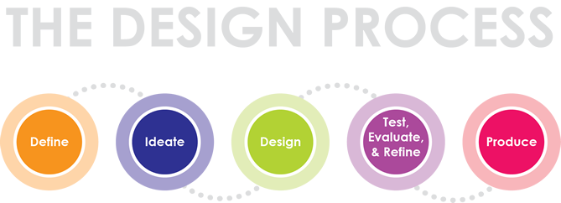

# 2. Define Phase

## 2.1 User Research and Analysis

**Research Methods Used**:

-***Surveys and Interviews***: Conducted with potential users to understand their needs and challenges during emergencies and further research on creating the app was done over the internet

**Key Findings and Insights**

- Users require a quick and intuitive method to report road status.

- Real-time alerts are essential for user safety, an integrated AI tool can offer immediate support for alternate route (if possible).

# 3. Ideate

## 3.1 Brainstorming

* **Techniques Used:** We utilized techniques such as brainstorming sessions and mind mapping with stakeholders to generate ideas for the DriveSafe app.
* **Key Ideas:** We focused on road signs and details, real time alerts, posting road updates and Mapping features.

## 3.2 Concept Development

* **Initial Concepts:** Created initial concepts and sketches derived from brainstorming sessions.
* **Evaluation**: Assessed concepts based on user needs and project goals to determine the most feasible solution.

## 3.3 Rough Sketching

Drawing by hand is the fastest way to visualize a concept so it should always serve as a backup method.

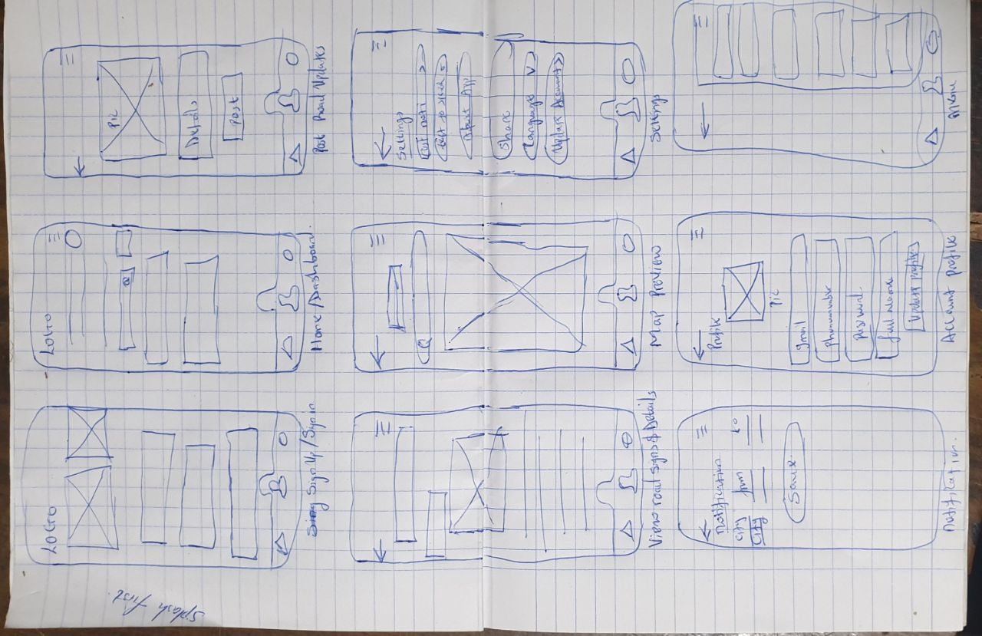

# 4. Design Phase

## 4.1 Wireframes

The wireframes provide a visual blueprint of the app's layout and structure, showcasing the placement of key elements such as weather forcast, status interface, and settings menu.

## 4.2 Digital Wireframing

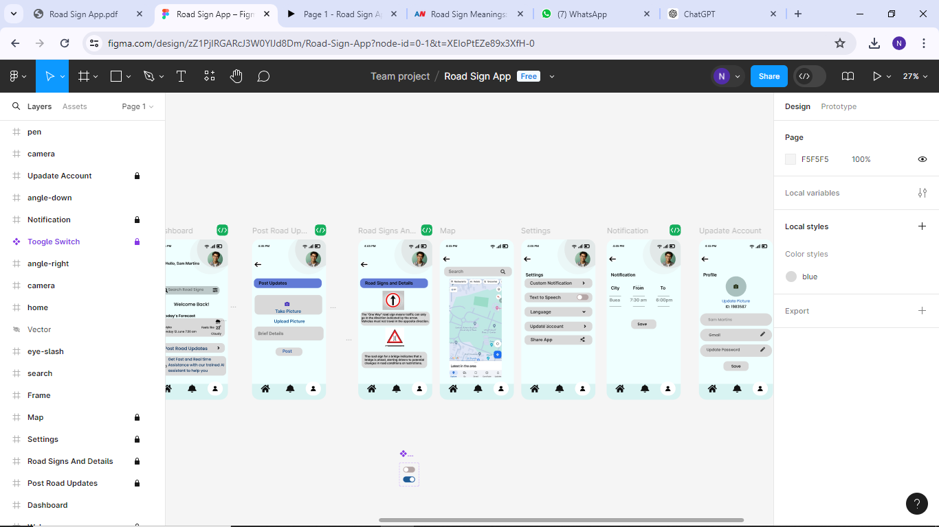

Low-fidelity wireframes are the simplest depictions of the user interface. Mid-fidelity wireframes provide more visual detail, and high-fidelity wireframes are the most detailed and visually refined representations of the user interface.

## 4.3 Typography

* **Font Family:** Inter
* **Font Weights and Styles:**
* Light (200): Used for secondary text and hints.
* Semi Bold (400): Used for body text.
* Medium (500): Used for Primary buttons and labels.
* Bold (500): Used for headings and Subheadings.

## 4.4 Color Scheme:

**● Primary Colors:** Blue(#007bff),White (#ffffff)

● **Secondary Colors**: Light Blue (#f0f8ff), Gray (#6c757d)

**Primary Color: Blue (#1D4ED8)**

* **Rationale**: Blue symbolizes trust, reliability, and safety, ideal for a road safety response app, instilling confidence in users and ensuring the provided information and services are credible. The chosen shade is vibrant yet not overpowering**.**

**Neutral Colors: Shades of Gray (#6B7280, #F3F4F6)**

**• Rationale:** Gray hues serve as backgrounds and secondary text to maintain a balanced and uncluttered interface, allowing primary content to stand out and creating visual hierarchies effectively.

## 4.5 Icons and Imagery

* **Icon Style:** Simple, clean, and filled icons, Simple line icons ensure quick comprehension without distracting from app functionality, maintaining a modern look.
* **Usage:** Icons for weather (cloud), search, Toggle, Camera for pictures, Realistic images aid in quickly identifying road sign types, enhancing user engagement and feature understanding.

## 4.6 Interaction Design

* **Buttons**: Rounded corners, blue for primary actions, grey for user actions.
* **Input Fields:** Rounded corners, clear labels and placeholders.
* **Pop-ups and Modals**: Transparent background, prominent action buttons.
* **Navigation**: Bottom navigation bar with icons and labels for Home, Profile, and Notification Setting.

## 4.7 Micro-interactions

* **Button Press**: Color change and shadow effect.
* **Loading Indicators**: Spinners or progress bars.
* **Error Messages**: Clear, concise, near the element causing the error.

# 5. Refine Phase

## 5.1 Prototyping

The high-fidelity prototype presents the polished visual appearance of the app, highlighting the color scheme, typography, and iconography used to create an intuitive and aesthetically pleasing interface. Screens include the home screen, Post Update screen, and Map view screen.

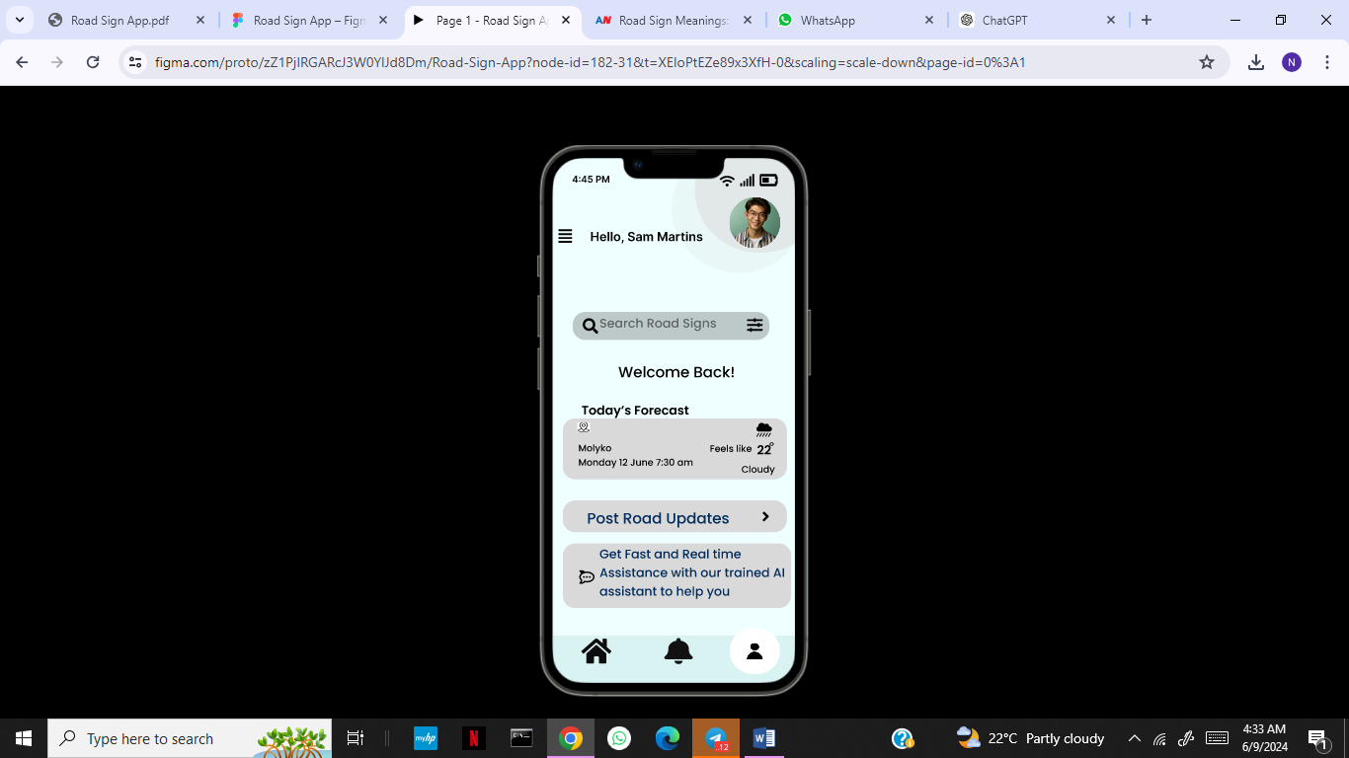

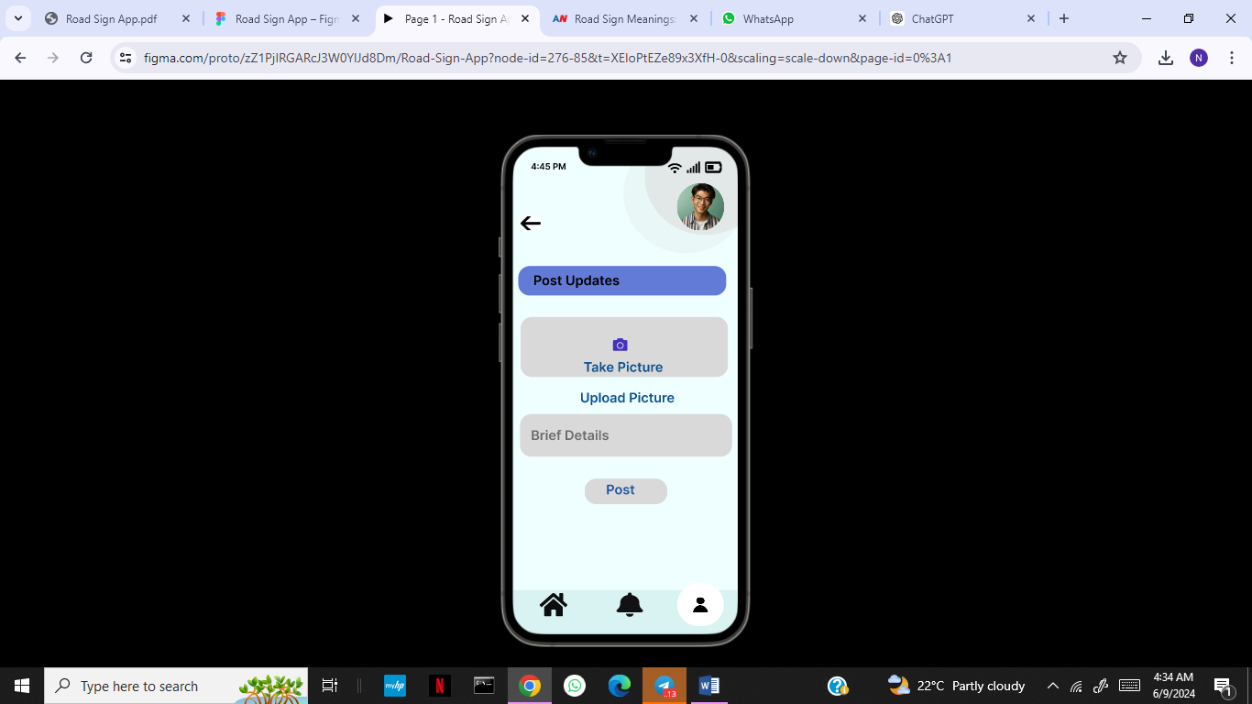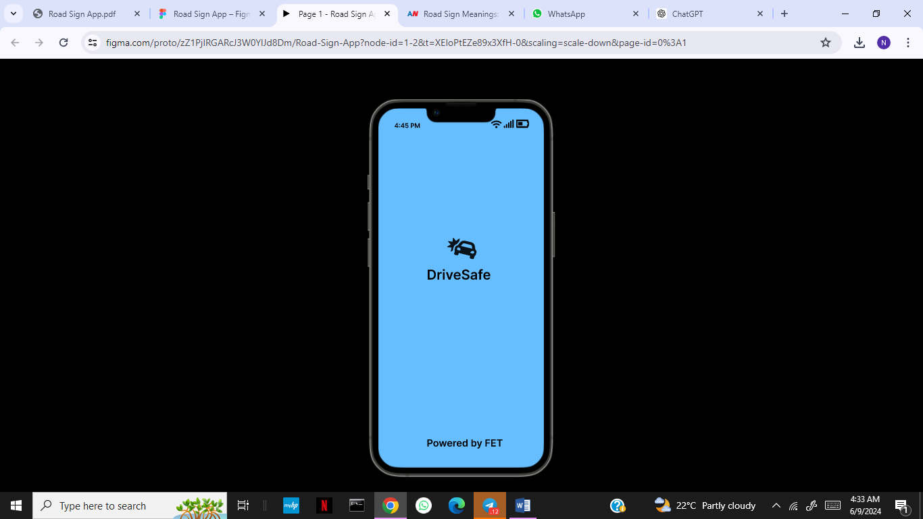

## 5.2 Iterative Feedback and Improvements

**User Feedback**: Collected feedback from initial prototype testing sessions within the team stakeholders, external stakeholders and potential users.

**Improvements**: Adjusted design elements based on user feedback, improved navigation flow, and refined visual elements for better usability.

# 6. Screens & Views

## 6.1 Screen Descriptions



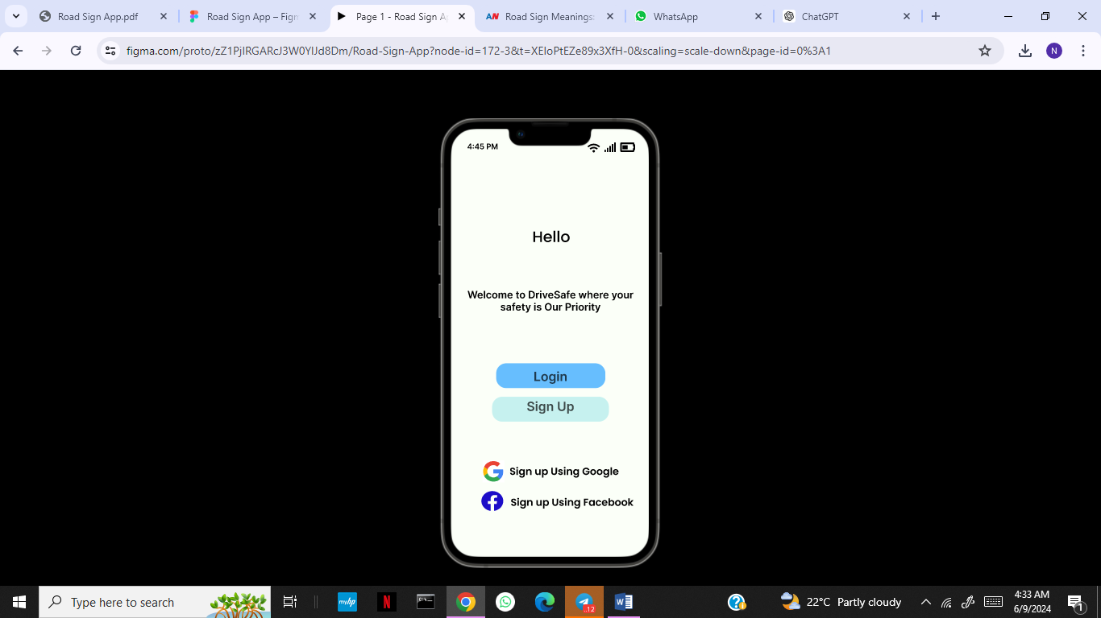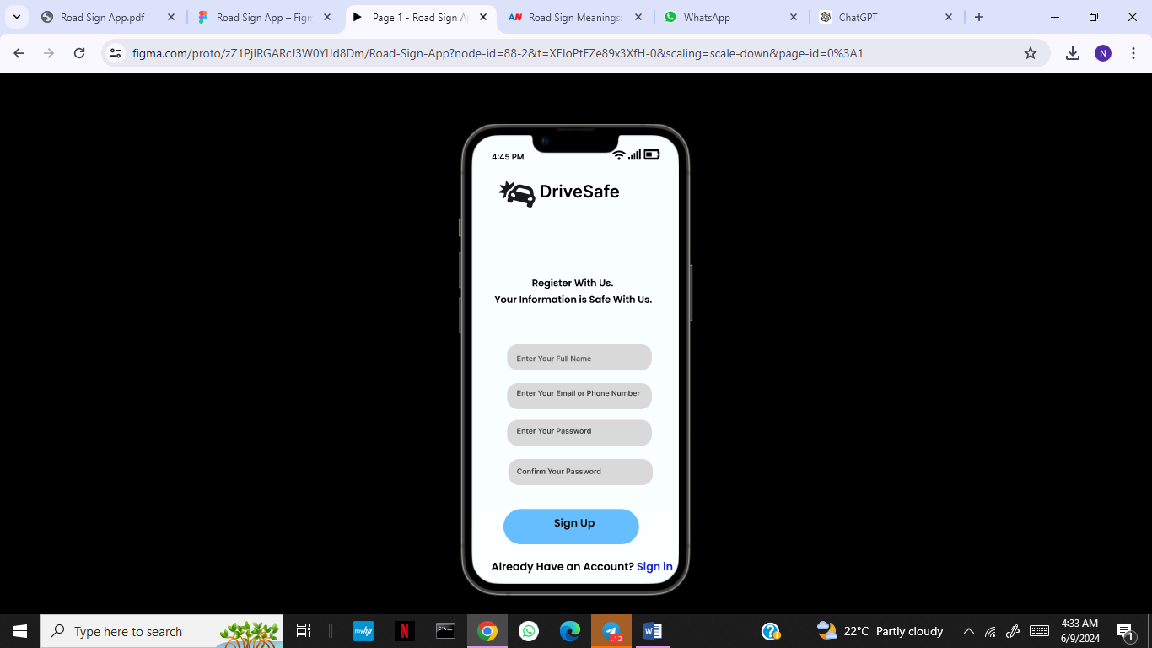

### Welcome Screen:

* + **Purpose:** Initial entry point of the app to greet users and set the tone.
  + **Components:** App logo, app name (DriveSafe).
  + **User Flow:** Users are introduced to the app with branding before proceeding to login or sign up.

### Login Screen:

* + **Purpose:** To allow existing users to access their accounts.
  + **Components:** Fields for email and password, login button, options for Google sign-in, and a link to the registration page.
  + **User Flow:** Users enter their credentials and log in, or opt to sign in with Google.

### Registration Screen:

* + **Purpose:** To enable new users to create an account.
  + **Components:** Fields for name, email, password, sign up button, and Google sign-up option.
  + **User Flow:** New users fill in the details to create an account or sign up using Google.

### Home Screen:

* + **Purpose:** The central hub where users can view forecasts, access AI, and access other functionalities.
  + **Components:** Weather forecast, Post road Updates and AI Assistant access.
  + **User Flow:** Users can view weather forecasts, post a road update, or interact with the AI Assistant from here.

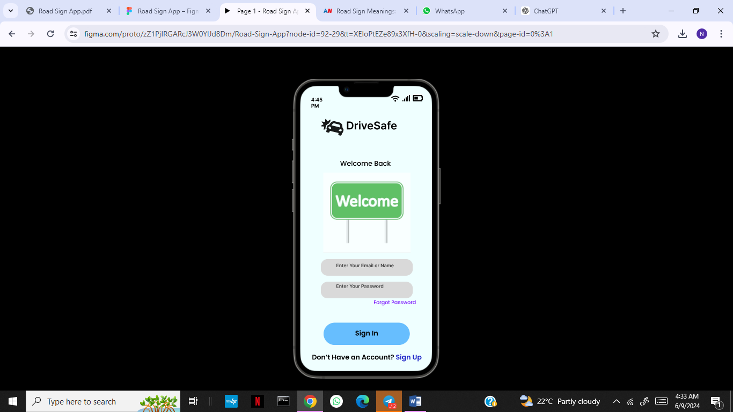



Post Update Screen**:**

* + **Purpose:** To allow users to report about road condition.
  + **Components:** Text input for additional details, location auto-detection, take picture and post alert button.
  + **User Flow:** Users enter details about road status and send the alert

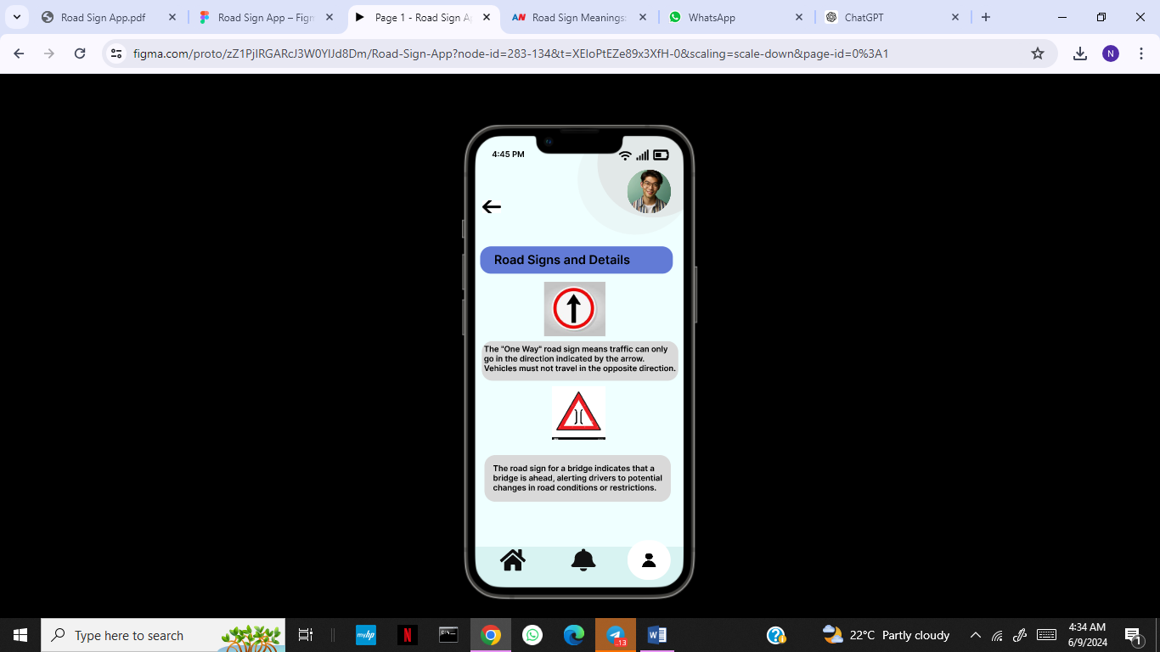

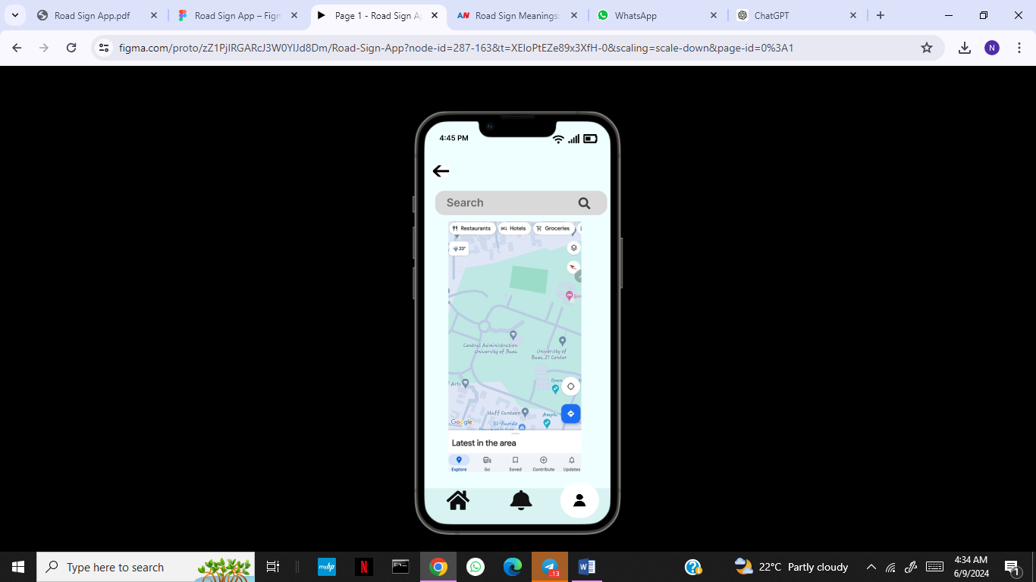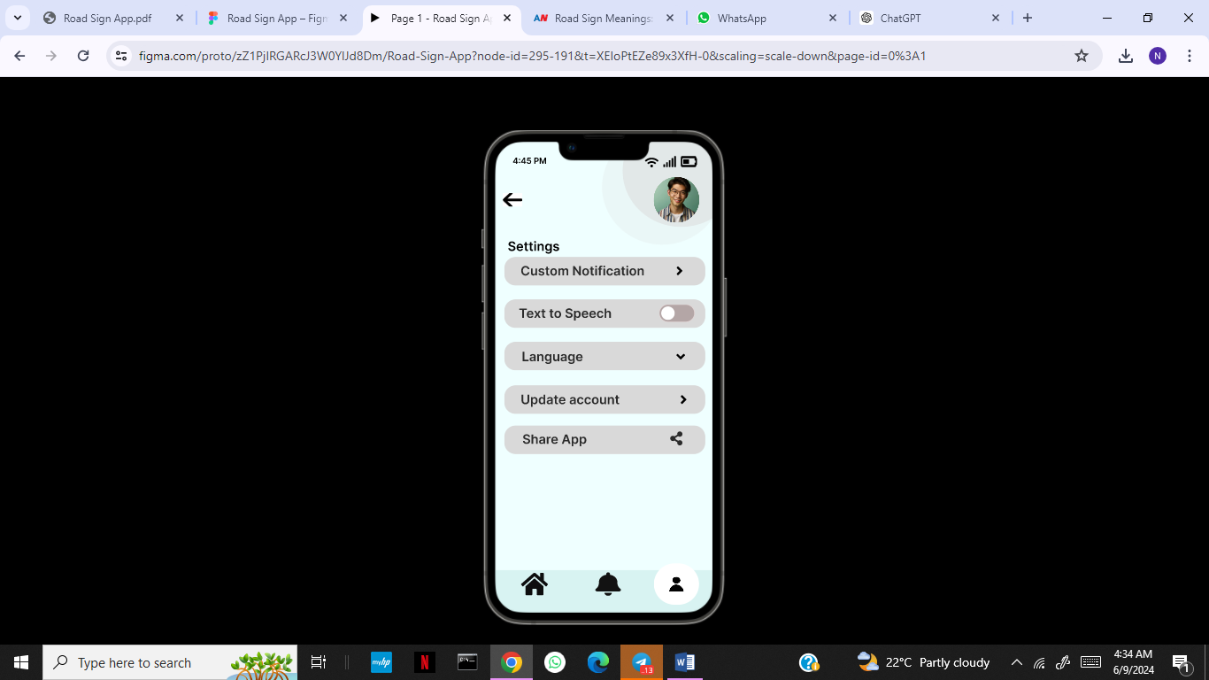

Weather Forecast Detail Screen:

* + **Purpose:** To provide detailed weather forecasts.
  + **Components:** Weather information for multiple days, detailed weather predictions.
  + **User Flow:** Users can view detailed weather forecasts.

Settings Screen:

* + **Purpose:** To allow users to manage their account settings.
  + **Components:** Options for changing account information, preferences, and app settings.
  + **User Flow:** Users can update their account information and customize their app experience.

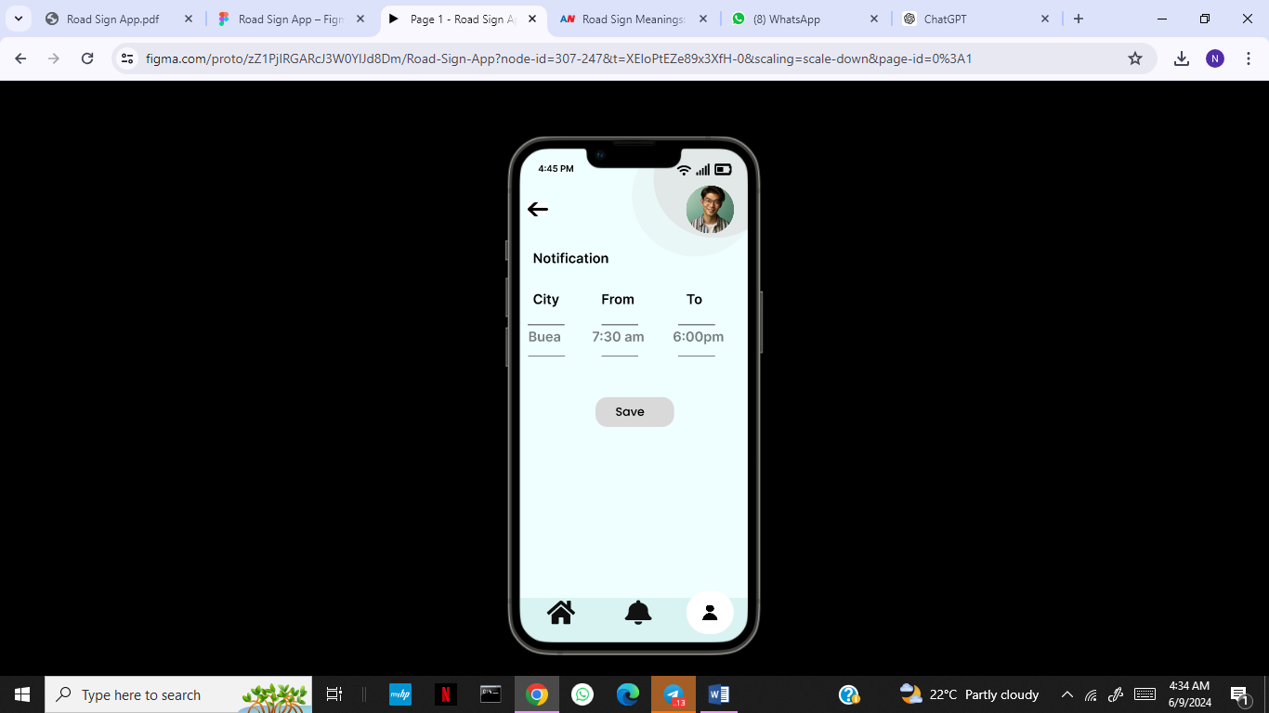

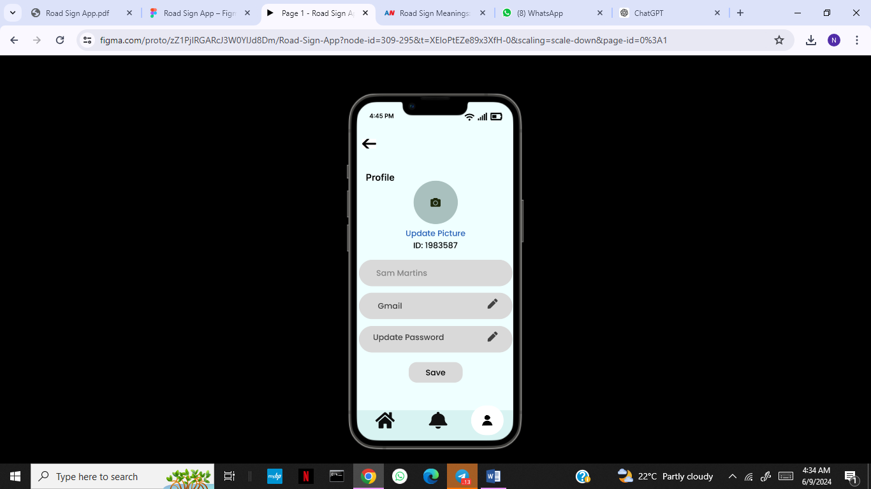

Custom Notification Screen:

* + **Purpose:** To enable users to receive custom alerts.
  + **Components:** Text input for custom alert details, location auto-detection, save alert button.
  + **User Flow:** Users enter details about their custom alert and send it.

# 6.2 Detailed User Flow (Screen flow)

## Login:

* + Users start at the **Welcome Screen** and proceed to the **Login Screen**.
  + They log in using their credentials or sign up if they don't have an account.

## Home Navigation:

* + Once logged in, users reach the **Home Screen** where they can view weather forecasts and post road updates.

## Browse Road Signs:

* + Users can browse from learn road signs from the database and see details

## AI Assistance:

* + Users can interact with the AI assistant from the **Home Screen** or the **AI Assistant Interaction Screen** for immediate help.

## **A**dditional Features:

* + Users can view detailed weather forecasts on the **Weather Forecast Detail Screen**.
  + Users can access accessibility features such as text to speech from the setting screen.
  + Manage settings and account details from the **Settings Screen**.

# 7. Test Phase

## 7.1 Usability Testing

* **Methodology**: Conducted usability testing sessions with stakeholders to assess the app’s functionality and user experience.
* **Key Findings**:
  + We found the emergency reporting process intuitive and quick.
  + The AI tool provided helpful first aid instructions.
  + Real-time alerts were effective in keeping users informed.
* **Adjustments Made**: Based on feedback, refined the placement of some elements, improved error messaging, and enhanced the accessibility features.

## 7.2 Accessibility Considerations

**Color Contrast**: Ensure sufficient contrast between text and background colors (minimum 4.5:1 ratio).

**Text Size**: Minimum font size of 14px for readability.

**Touch Targets**: Minimum 44x44 pixels for touch targets to ensure they are easily tappable.

**Alternative Text**: All images and icons have descriptive alt text for screen readers.

**Keyboard Navigation**: Ensure all interactive elements can be accessed via keyboard.

# 8. Conclusion

The DriveSafe app aims to provide a reliable and user-friendly platform for road condition Updates and real-time alerts. By adhering to our detailed design guidelines and user-centered approach, we ensure that the app meets the needs of our target audience while providing an intuitive and accessible experience. Our comprehensive wireframes, prototypes, and visual design standards serve as the foundation for delivering a high-quality application that enhances community safety and responsiveness.

**References:**

Shneiderman, B., Plaisant, C., Cohen, M. S., Jacobs, S., Elmqvist, N., & Diakopoulos, N. (2018).

Designing the user interface: strategies for effective human-computer interaction. Pearson.

• Dario Calonaci (2021). Designing User Interfaces: Exploring User Interfaces, UI Elements,

Design Prototypes and the Figma UI Design Tool (English Edition)

• https://bootcamp.uxdesign.cc/ consulted on “11 march 2024”

**• https://www.geeksforgeeks.org/guide-for-figma-interface/ consulted on “11 march 2024”**